GEOPROCESSAMENTO APLICADO NA ADEQUAÇÃO DO USO DAS TERRAS ATRAVÉS DE ANÁLISE MULTICRITÉRIOS

1 RESUMO

Esse trabalho objetivou a análise da adequação do uso de terras de uma microbacia pelo método de análise de multicritérios através do Sistema de Informação Geográfico (SIG) – Idrisi Andes 15.0, tendo como base cartográfica digital em escala 1:50000; o mapa de uso da terra do microbacia em uma balança semi-detalhada e imagens do Landsat 7 satélite de ETM+. Os critérios usaram (restrições para a exploração agrícola): áreas de preservação permanentes, rede de estrada, uso da terra, declividade e cobertura vegetal. Para a análise de multicritérios, os métodos usados foram Processo de Hierarquia Analítico (AHP) e combinação linear ponderada (ACL), na plataforma de processamento em SIG. Os resultados permitiram concluir que o ambiente apresenta características agrícolas e ambientais devido, principalmente, a ampla extensão de terra disponível para uso agrícola.

Palavras chave: planejamento ambiental, Processo de Hierarquia Analítico, combinação linear ponderada.

2 ABSTRACT

This paper aims to investigate the suitability of land use in a watershed by using the multicriteria decision analysis processing in a geographic information system (GIS) - 15.0 Idrisi Andes. The data selection and acquisition was based in a digital map product adopted in a 1:50000 scale; in a soil use watershed map; in a semi-detailed soil mapping, and in a Landsat 7 ETM + satellite image. The criteria set was based on some restriction to the farm management: permanent preservation areas, main roads, land use, slope and vegetation cover. This conflict was been resolved by applying the multicriteria analysis using a weighting procedure such as the analytical hierarchy process (AHP) and the linear weighting combination (FTA), in a GIS processing. The results showed that the environmental shows agricultural and environmental characteristics, mainly due to the large extension of land available for agricultural use.

Keywords: environmental planning, analytical hierarchy process, linear weighting combination

3 INTRODUCTION

The multicriteria analysis has been used in several studies related to environmental planning as: the definition of the areas suitable for enterprises establishment, environmental risk analysis, environmental sensitivity analysis and planning the land use (Malczewski, 2004; Eastman, 2003; Collins et al, 2001; Jang e Eastman, 2000).
Malczewski (2004) states that analysis of the suitability of the land use with GIS has application in various situations with ecological thoughts, as the determination of habitat for plant and animal species, suitability of land for agriculture, assessment and planning the landscape, evaluation of the environmental impact, and regional planning. Targeting the appropriately designed for land use, three approaches can be used in a GIS processing, as: overlapping spatial information, artificial intelligence and multi-criteria evaluation method. The multicriteria analysis is a mathematical tool for comparing different alternatives (or scenarios) based on various criteria, in order to direct decision makers to choose a more considered way for land use (Roy, 1996).
The integration between the methods of multicriteria analysis and GIS has been an advance in methodology for processing layers to determine the suitability of land use. The GIS-based multicriteria decision analysis (MCDA) is a choice of one or more alternatives made from a set of geographically defined alternatives (events). The spatial data are combined and transformed considering a given set of evaluation criteria for decision making and management of the environment.
This study had as main objective to analyze the soil use using the multicriteria analysis as agricultural suitability, relevant relief characteristics and the land use in a watershed, using multi-criteria analysis in GIS processing.

4 MATERIAL AND METHODS

The Arroio Ajuricaba watershed is located in the Marechal Cândido Rondon County, Paraná State, Brazil, in a Universal Transverse Mercator (UTM) geographic coordinate system from 787309 m E to 793892 m E; and 7275026 m N to 7281310 m N, 21 S Zone; occupying an area of 1681 hectares.
The relief is predominantly smooth-undulating (45%), 30% undulating, 15% plan, and 10% strongly undulated, and the soil classes occurring in the region are Red Nitossolos and Entisols (Marechal Cândido Rondon, 2005). The clime is humid subtropical, mesothermal (Cfa), according to Koppen. The average annual temperature is 21 º C, while the average minimum is 15 ° C and average maximum is 28 ° C. The annual precipitation is 1,500 mm (IAPAR, 1978) and the native vegetation cover is a Semideciduous Stacional Forest.
The cartographic base maps were: a digital topographic map of the Marechal Cândido Rondon County (SG.21-XB-VI-2), scale of 1:50000; a soil map in a semi detail scale (Souza, 2004), with nine soil classes (Figure 1), according to the Brazilian System of Soil Classification (EMBRAPA, 1999); a digital satellite image of Landsat 7-ETM +, dated on 01/28/2000), orbit / point 224/077. The data was processed in the AutoCAD 2004 software and at the Idrisi sELVA geographic information system.
In analyzing the suitability of the land use in the watershed, it has been used the following data: land agricultural suitability, land use, slope, areas of permanent preservation (APPs) and main roads.

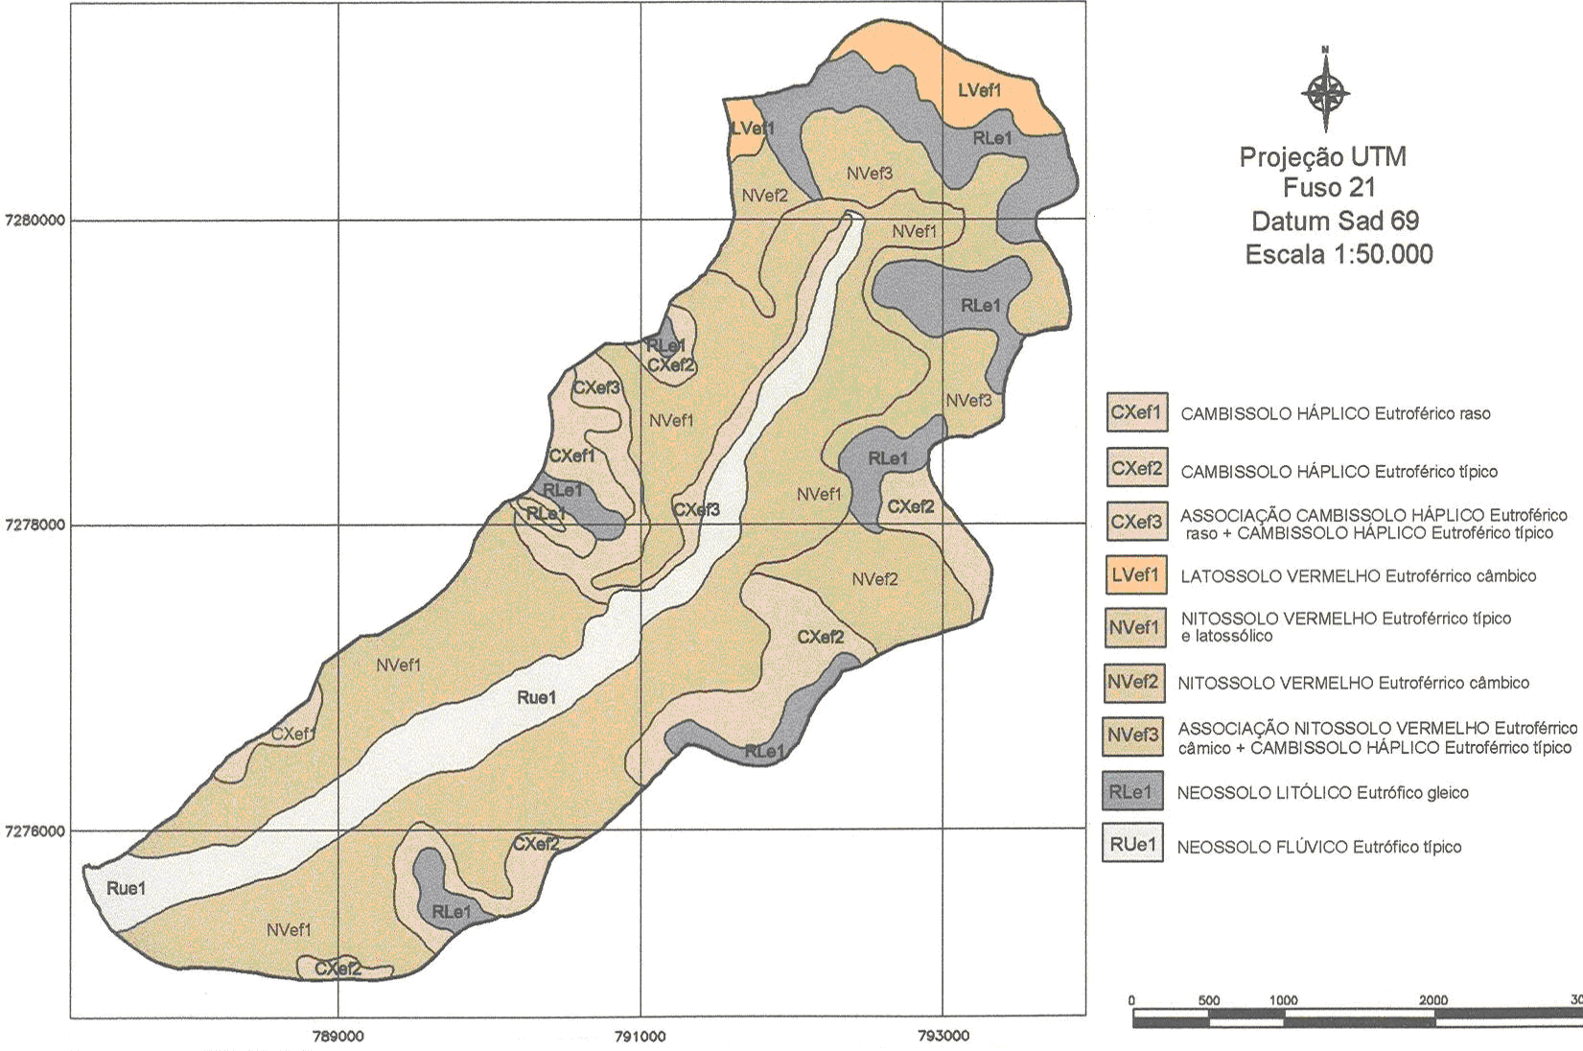
Figure 1. Soil map of the Arroio do Ajuricaba watershed, Marechal Cândido Rondon County, State of Paraná (PR), Brazil.

The agricultural land suitability (Figure 2) was determined based on the soil map of the watershed (Ramalho Filho and Beek, 1995).
The processing map for the interpretation of the layers of the land use was made using a satellite image of Landsat 7-ETM + georeferenced on visible red, near infrared and mid infrared spectrum (3, 4 and 5), for processing the composition of RGB-543, to facilitate the visual interpretation of the image and to take the training samples, by means of digitizing polygons on the screen in the representative areas of each class of land use: native vegetation, annual crop, bare soil / planting new crop, pasture, water and roads. The next step consisted of automatic classification in a GIS, using the maximum likelihood algorithm, with the option of equal probability of occurrence for each spectral signature, and a ratio of exclusion of the pixels from 0%, classifying, in this way, all the pixels of the image (Figure 3).
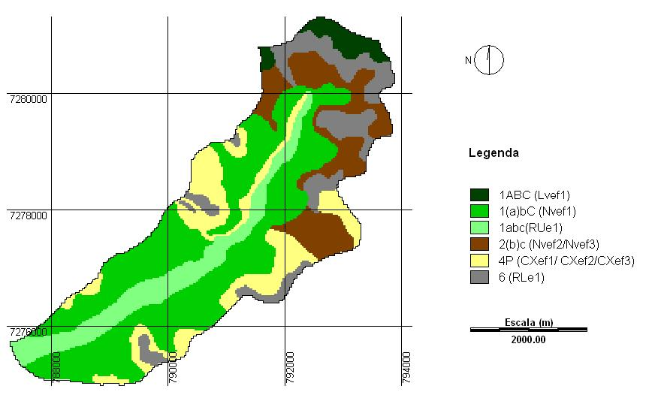
Figure 2. The agricultural land suitability map of the Arroio do Ajuricaba watershed, Marechal Cândido Rondon County, State of Paraná (PR), Brazil.
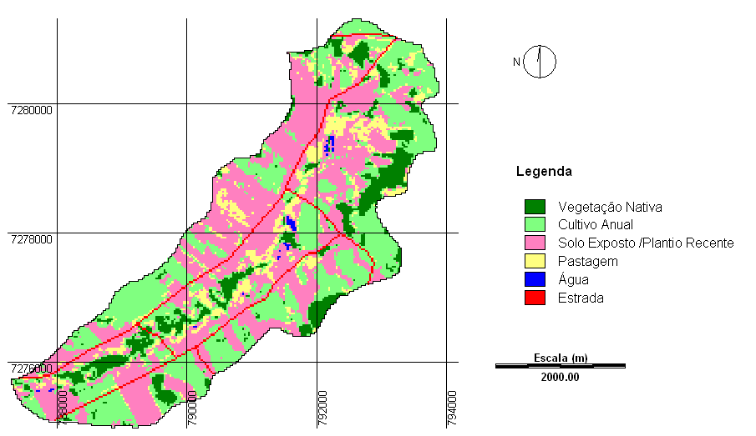
Figure 3. The land use classification map of the Arroio do Ajuricaba watershed, Marechal Cândido Rondon County, State of Paraná (PR), Brazil.

The slope map (Figure 4) was prepared based on the slope classes recommended by Ramalho Filho and Beek (1995).
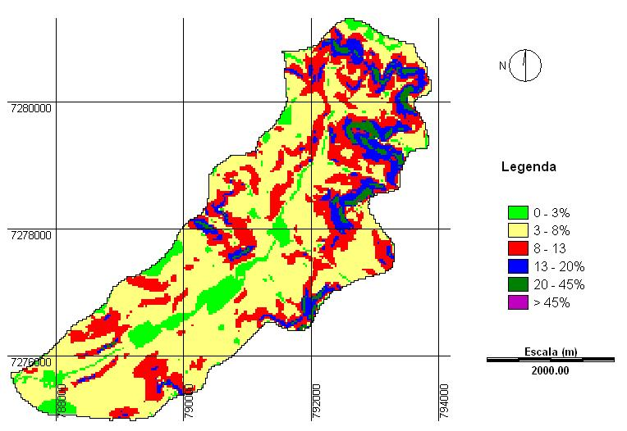
Figure 4. Clinograph Map of the Arroio do Ajuricaba watershed, Marechal Cândido Rondon county, State of Paraná (PR), Brazil.

The next step was to combine all of the criteria grids within each area of concern. The created criteria was identified in two groups: those that confer a total restriction to the farm agricultural land management, regardless of use or soil management; and those with shows some degrees of suitability grids for the same purpose (factors). Thus, the restrictions were considered: water supplies, areas of permanent preservation (APPs) and the main roads. The method for create the maps has been used a Boolean scale, attributing the value 0 to the restrictions and 1 for others.
The criteria relating to the areas of permanent preservation (APPs) were based on Resolution No.. 303 from CONAMA (2002) and in a Federal Law N º. 4771 (BRASIL, 1965).
Unlike the restrictions, which have well defined limits (adequate or inadequate), the maps of the factors determine solid surfaces, which represent a gradual variation of the suitability of the land use, based on an increasing scale of values ranging from 0 (least appropriate) to 255 (more appropriate), being considered as factors: the land suitability, the land use and the slope established in four classes of suitability: high, medium, low and restrict.
Classes with different degrees of suitability for farming, 1ABC, 1(a)bc and 1abc were grouped into one unique class and received the value of 255 (higher suitability for faming). For class 2(b)c (regular suitability for farming) has been established a value of 170 (medium). The class with the suitability to pasture (4P) received the value of 85 (low), and the class 6 (without agricultural suitability) the value 0 (restricted).
For the factor of land use was used as evaluation criteria the greater or lesser degree of erosion protection that each type of vegetation covers (current use) provides to the soil (Bertoni and Lombardi Neto, 1990). The areas covered by native vegetation and pasture had received a value of 255 (high) and 170 (average), respectively. Areas with annual crop and bare soil (newly planted), grouped in a single class, received the value of 85 (lower suitability), because they are used for annual crop.
For the factor of slope was used as an evaluation criteria the range of classes established in the system for suitability of agricultural land use, proposed by Ramalho Filho and Beek (1995). These classes allowed to infer that the slope below 20% are suitable for agricultural use, from 20% to 45% conferring a lower suitability because they show some difficulties for the tillage and mechanization, while 45% are considered inappropriate for this activity, and they should be designed for other uses. These criteria allowed establishing the appropriateness of the slope land use classes (Table 1).

Table 1. Slope land use classes of suitability of the land use of the Arroio do Ajuricaba watershed, Marechal Cândido Rondon county, State of Paraná (PR), Brazil.
Range of slope classes (%) | Suitability of land use
Range of slope classes (%) | Values | Classes
0 a 13 | 255 | High
13 a 20 | 170 | Medium
20 a 45 | 85 | Lower
> 45 | 0 | Restrict

The next step was to examine the influence of each criteria in the process of the suitability evaluation of the land use.
The methodologies share similar steps of organization and decision matrix construction, but each methodology synthesizes information differently. The weight was made using a pairwise comparison matrix, where each cell is filled with a trial value that expresses the relative importance between pairs of criteria. The definition of the values of importance among the criteria determines the input data matrix and, from them, the relative weights of each factor is calculated (eigenvector of the matrix) and the consistency of the trial of the matrix (maximum eigenvalue of the matrix). Thus, a matrix of pairwise was processed in a GIS, using as basis a continuous 9-point scale reflecting the relative importance among them: 1 / 9 (Extremely), 1 / 7 (strongly), 1 / 5 (strong ) 1 / 3 (little) 1 (equal importance), 3 (little) 5 (strong), 7 (strongly), 9 (extremely). Based on this scale, the devised weight matrix was processed, as shown in Table 2.

Table 2. Weight matrix of the factors.
Factors | Land Use | Slope | Agricultural Suitability
Land Use | 1 |  | 1/7
Slope | 3 | 1 | 1/3
Agricultural Suitability | 7 |  | 1

After comparing the factors, two by two, the relative weights for each one were calculated, using the AHP (Analytical Hierarchy Process). Each parameter is associated with a scale factor that represents the relative importance or degree of influence of that parameter to the overall measure of site suitability. This procedure was performed by means of GIS, which has a similar structure to the Saaty (1980) method. Apart from the relative weights that were pondered, the software allows to calculate the consistency ratio of the matrix that, according to Saaty and Vargas (1991) must be less than 0.1. The consistency ratio (CR) indicates the probability that the evaluations of the matrix were randomly generated. The last step was the evaluation of multi-criteria by the method of weighted linear combination, and in multiplying this result by restrictions, excluding in this way, areas of restricted use.

5 RESULTS AND DISCUSSION

The relative weights calculated from the factors pairwise comparison matrix, for the factors: land use, slope, and agricultural suitability were: 0.09, 0.24 and 0.67, respectively. The consistency ratio (CR) of the relative weights determined in this study was 0.01, indicating that the trial had acceptable consistency, less than 0.1 (10%). The results allowed observing that the land suitability and slope factors showed higher weights (0.67 and 0.24) in relation to land use (0.09). These values express the importance of each criteria for evaluating the suitability of land use.
This resulting weighted composition grid retains the values from all input suitability classes (Figure 5), representing a continuous area of agricultural land use suitability, with values ranging from 0 to 255. The value 0 is the restriction to total farming management land, increasing gradually to 255, that is the high-value adjustment for land use.
The map (Figure 5) was reclassified into four classes (restrict, low, medium and high), for a better analysis of the watershed areas that are being used properly or not, according to specific criteria for this study resulted in the final map of suitability land use (Figure 6). Those lands in each suitability were selected and quantified.
Most of the area showed values from medium to high degree of suitability, and the areas as high suitability for agricultural use have to be distributed throughout the watershed, most concentrated in the southwestern part. The ones with medium suitability occur in portions of eastern, western and southern areas, and the ones that shows lower suitability are shown to the east, west and southeast, with the highest concentration is in the northern portion, where the terrain ranges from undulating, strong undulating to a hilly strongly area.
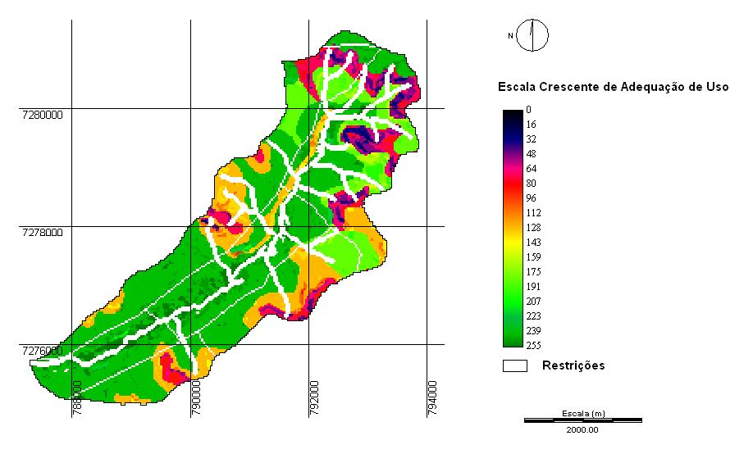
Figure 5. Map of suitability classes for agricultural use of the Arroio do Ajuricaba watershed, Marechal Cândido Rondon county, State of Paraná (PR), Brazil.

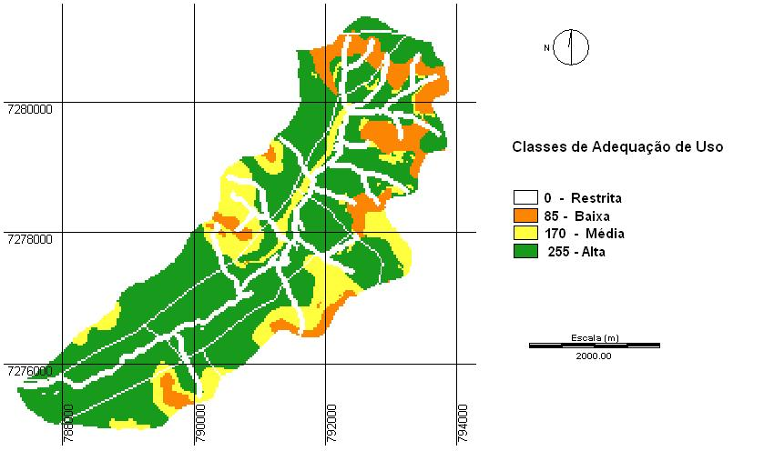
Figure 6. Map of suitability classes for agricultural use of the Arroio do Ajuricaba watershed, Marechal Cândido Rondon county, State of Paraná (PR), Brazil.

The map of suitability classes for agricultural use (Figure 6) shows that 58.54% has high suitability for agricultural use; medium 15.48%, 10.98% lower and 15% restricted. The data also show that 10.98% of the area had low suitability. The areas of total restriction for agricultural land use (water bodies, roads and APPs), regardless of use or soil management, is shown in 15% of the total area of the watershed.

6 CONCLUSIONS

The area has a potential use for agricultural use, mainly due to its good soil conditions and topography, with 71.94% for suitability for using the land with annual crops, taking into account the different types of management. The remaining area (15.85%) is recommended for use with less intensive agricultural activities (pasture, forestry and / or natural grassland). Areas unsuitable for agricultural use (12.21%) have restrictions on their soil, because of shallow depth and strong undulating to hilly topography. Those areas area supposed to be designed for other purposes, such as permanent crops or preserving the flora and fauna, as that under more intensive use, can cause fertility problems and erosion. The evaluation of land use refers to the legal reserve of the watershed, showed a smaller area than that established by the Brazilian Forest Code, indicating the need of planting native species. The criteria were adequate, however, suggests that other criteria are also used in the analysis to improve the methodology.

7 BIBLIOGRAPHICAL REFERENCES

BERTONI, J.; LOMBARDI NETO, F. Conservação do solo. São Paulo: Ícone, 1990. 355p.
BRASIL. Lei Federal nº 4.771, de 15 de setembro de 1965 – Código florestal. 1965. Disponível em <http://www.mma.gov.br/conama.> Acesso em 06 de outubro de 2005.
COLLINS, M. G., STEINER, F. R., RUSHMAN, M. J. Land-use suitability analysis in the United States: historical development and promising technological achievements. Environment Management, v. 28, n. 5, p. 611-612, 2001.
CONAMA – Conselho Nacional do Meio Ambiente. Resolução Nº 303, de 20 de março de 2002 – Dispõe sobre parâmetros, definições e limites de áreas de preservação permanente. Disponível em: <http://www.mma.gov.br/conama> Acesso em 06 outubro de 2005.
EASTMAN, J. R. Idrisi Kilimanjaro: guide to GIS and image processing. Worcester: Clark University, 2003. 328p. Manual Version 14.00
EMBRAPA. Sistema brasileiro de classificação de solos. Centro Nacional de Pesquisas de Solos.. Rio de Janeiro (RJ), 1999. 412p.
IAPAR - Fundação Instituto Agronômico do Paraná. Cartas Climáticas Básicas do Estado do Paraná. Londrina, PR, 1978
JANG, H.; EASTMAN, J. R. Application of fuzzy measures in multi-criteria evaluation in GIS. International Journal of Geographical Information Science. v. 14, n. 2, p.173-184. 2000.
MALCZEWSKI, J. GIS - based land-use suitability analysis: a critical overview. Progress in Planning. v. 62, n. 1, p. 3-65, Jul. 2004.
RAMALHO FILHO, A.; BEEK, K. L. Sistema de avaliação da aptidão agrícola das terras. 3ª ed. – Rio de Janeiro: EMBRAPA – CNPS, 1995. 65p.
SOUZA, M. L. P. Levantamento de solos e do risco ambiental das terras da sub-bacia do Córrego Ajuricaba, município de Marechal Cândido Rondon-PR. Programa Cultivando Água Boa _ ITAIPU. TERRA-Planejamento Ambiental Consultoria Agronômica. Curitiba – PR, 2004.

